Dear designers, please contribute to open source

So many open source projects are poorly designed. We need help from designers to make the experience enjoyable for the users.



An [open-source](https://en.wikipedia.org/wiki/Open-source_software) project is typically a collaborative effort where programmers improve upon the source code and share the changes within the community so other programmers can improve it further. The software is free to distribute and modify.

Many open source softwares are made with little or no contribution from professional designers, ugly looking interfaces and leading to poor User Experience. There are thousands of very cool open source projects which are poorly designed and hence common people are not able to use them.

Look at these two applications. Both of them are really powerful tools.

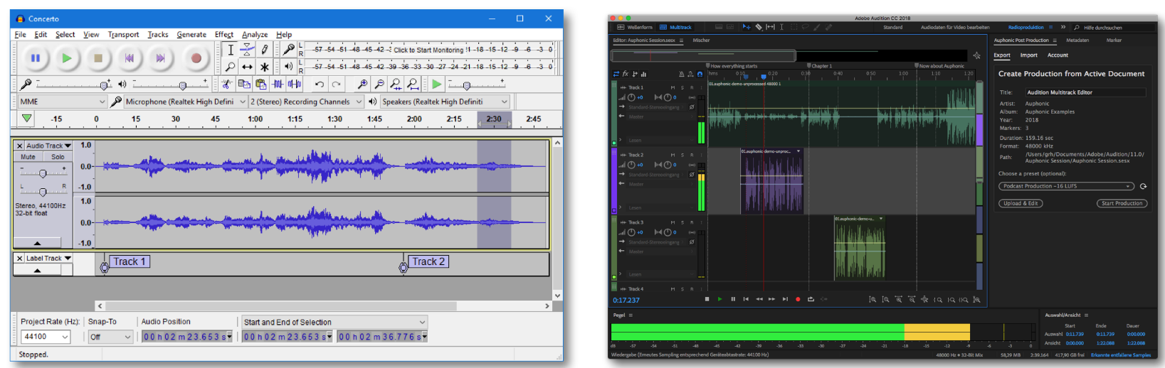

According to a [website](https://www.trustradius.com/compare-products/adobe-audition-vs-audacity) which compared these tools, a user said (*for the left image)*:

*The interface isn’t the worst I have seen but the UI isn’t exactly enjoyable on Mac or PC*

Even if you look at tools like OpenOffice or LibreOffice the interface looks a bit dated.

**Why designers are not able to contribute:**

A big issue here is awareness. I talked to my friends who are designers and they are ready to do design projects which are doing good but they don’t know that these types of projects even exist.

Next problem is discovery. Some designers are really interested in contributing to open source projects but they don’t know about where to find open-source projects who have design-related issues and on what feature or issue they can work on.

Another thing is that they don’t know about git, PRs, issues and other complex words like these. And when somebody goes to a GitHub repository looking for an issue, it’s all overwhelming. You need to know some basics of [git](https://git-scm.com/" \t "_blank). There is a [website](https://try.github.io/) from GitHub to try git.

**How designers can get started:**

The current OSS world is too much developer centred and there is no support for things related to product design or icon design. But still, some designers are contributing and people really appreciate them.

One way of contributing is to open an issue on the project repository and tell maintainers about your idea. You can also report bugs related to the project and they are counted as a contribution as well.

You can also help define a style guide to help the project have a consistent visual design. You can also help in creating logos or icons for open source projects. You can even design t-shirts like the way [hapi.js contributors did](https://github.com/outmoded/hapi-contrib/issues/68).

[**Luigi Baute**](https://github.com/LuigiBaute)opened an [issue on TheAlgorithms repo](https://github.com/TheAlgorithms/Python/issues/297) and he wanted to make a logo for the organisation.

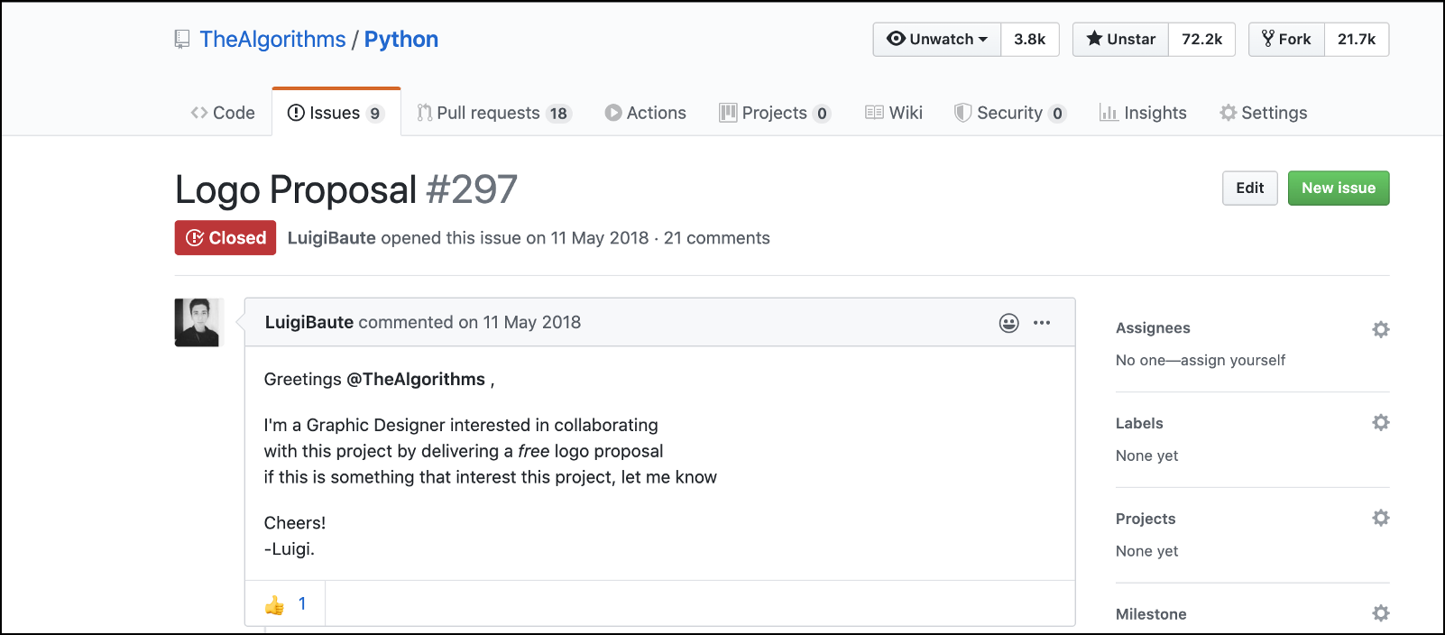

Logo proposal issue on [GitHub](https://github.com/TheAlgorithms/Python/issues/297)

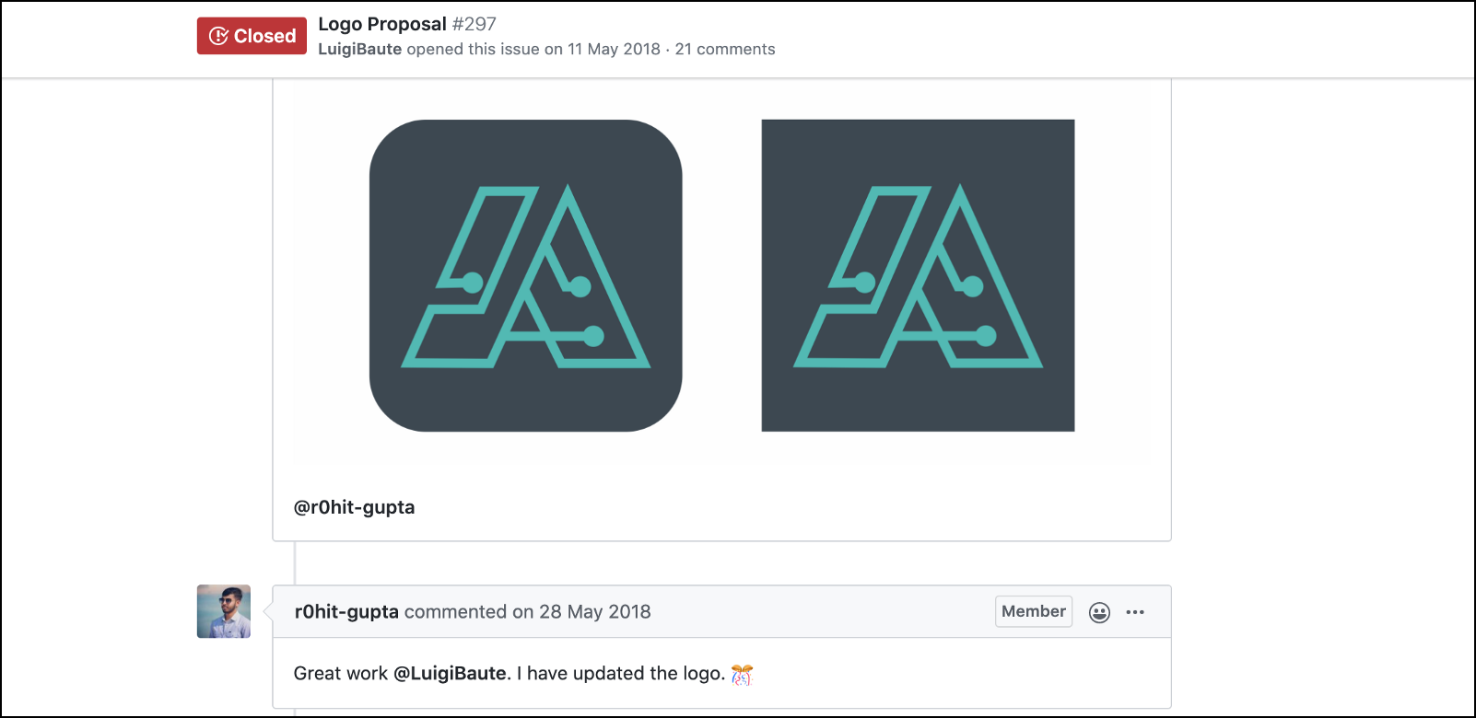

The logo was [accepted](https://github.com/TheAlgorithms/Python/issues/297#issuecomment-392484206) and maintainers updated the organisation logo.

Finally, after doing some changes his logo was accepted and the organisation logo was changed. He also wrote a [blog](https://steemit.com/utopian-io/@stephenhawking/new-logo-for-the-algorithms) on this.

Designers can also look at [*https://opensourcedesign.net/.*](https://opensourcedesign.net/)They have project listings for work related to designs and UX research.

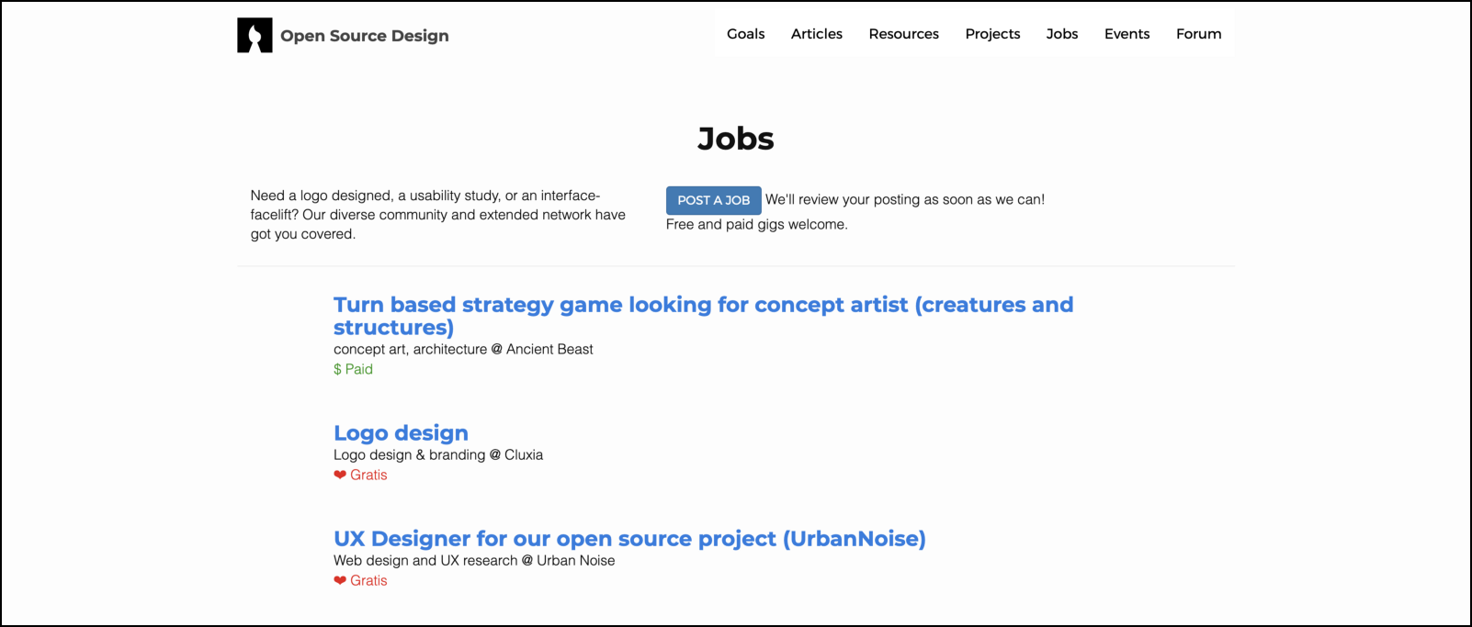

Screenshot from [open source design](https://opensourcedesign.net/) jobs board.

Organisations like Mozilla have well-defined issues related to design and graphics. <https://github.com/mozilla/OpenDesign/>. Who knows your design can be on the next Firefox homepage.

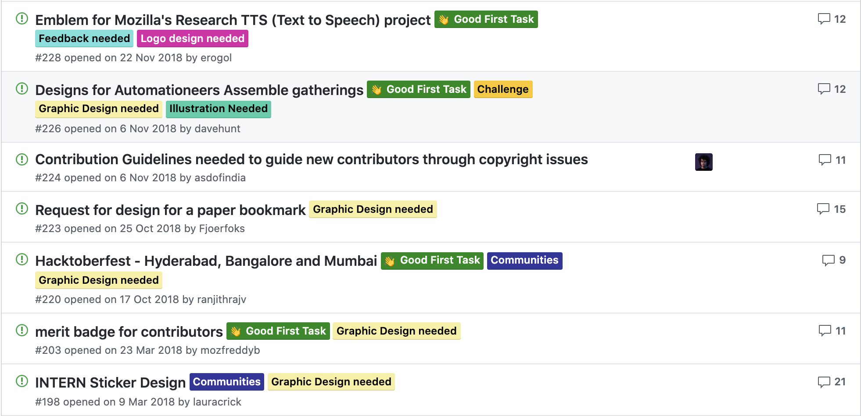

**What open source projects need to do:**

Project maintainers and owners should encourage these type of contributions by being clear about what kind of help they need from designers and have some framework to review the design work.

They can make detailed issues in the project and tag them with related tags. Organisations should have defined process that enables designers to contribute in the end to end product life cycle.

Drupal has done this excellently. They have a [webpage](https://www.drupal.org/community-initiatives/drupal-core/usability) for UX research and they post detailed information on how designers can contribute to Drupal. Some other organisations are also actively encouraging designers to work with them. To name a few — [Mozilla](https://blog.mozilla.org/opendesign/), [Zulip](https://github.com/zulip/zulip" \t "_blank), [Wikimedia](https://www.mediawiki.org/wiki/Design/Participate).

Since most developers are not designers they ship anything which looks good to them and the pull request reviewer, they should introduce a design review process before having any UI/UX related change to the product.

**Happy Shipping ⚓️⛴**